

**ASSIGNMENT NO:1**

**STUDENT NAME:** Sadia Ejaz

**REGISTRATION**#: FA24-BBA-050

**Class:** BBA (B)

**SUBJECT**:

**PROGRAMMING LANGUAGE FOR BUSINESS**

**ANALYTICS**

Submitted to: **SAMEET FATIMA**

Department: **MANAGEMENT SCIENCES**

**ACTIVITY NO:1**

Class Activity: Weekend Getaway to Murree

**Q.1: How can you break down the trip planning process into smaller, manageable tasks?**

1. Decide travel dates.
2. Arrange transportation (car/bus).
3. Book accommodation (hotel/guest house).
4. Estimate budget (travel, stay, food, activities).
5. Pack essentials (clothes, medicines, snacks).
6. Plan sightseeing spots (Mall Road, Patriata, Kashmir Point).
7. Ensure safety (check weather, emergency contacts).

**Q.2: What patterns can you identify from your past travel experiences?**

1. Every trip requires **transport + accommodation + food**.
2. **Weather** often affects plans → pack accordingly.
3. **Unexpected delays** → always keep buffer time.
4. **Budget overruns** → always carry extra cash.
5. **Group coordination** is necessary → divide responsibilities.

**Q.3: What are the essential elements to consider when planning a trip?**

1. **Where**: Murree
2. **When**: Weekend (Sat-Sun)
3. **How**: Travel method (car/bus)
4. **Stay**: Hotel booking
5. **Budget**: Estimated cost (travel + stay + food)
6. **What to do**: Sightseeing, shopping, food
7. **Safety**: Weather check, medicines, contacts

**Q.4: How can you create a step-by-step plan to ensure a successful trip?**

* 1. Select travel dates.
  2. Arrange transportation (book seats in bus or confirm car).
  3. Book accommodation in advance.
  4. Set budget and withdraw cash.
  5. Pack clothes, snacks, and medicines.
  6. Start journey early morning from Islamabad.
  7. Check in at hotel.
  8. Visit sightseeing locations (Mall Road, Kashmir Point, Patriata).
  9. Have dinner and rest at hotel.
  10. Next day: breakfast and final sightseeing.
  11. Return home in the evening.
  12. Review expenses and memories

**ACTIVITY NO:9**

**Question**: Write a program to check if a number is positive, negative, or zero.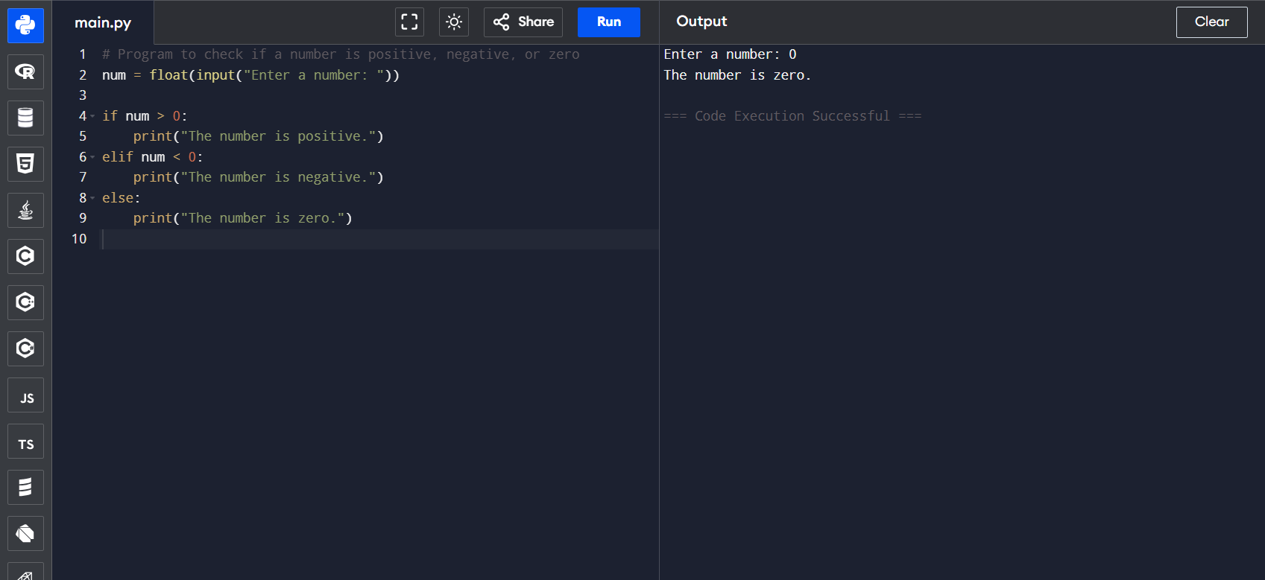

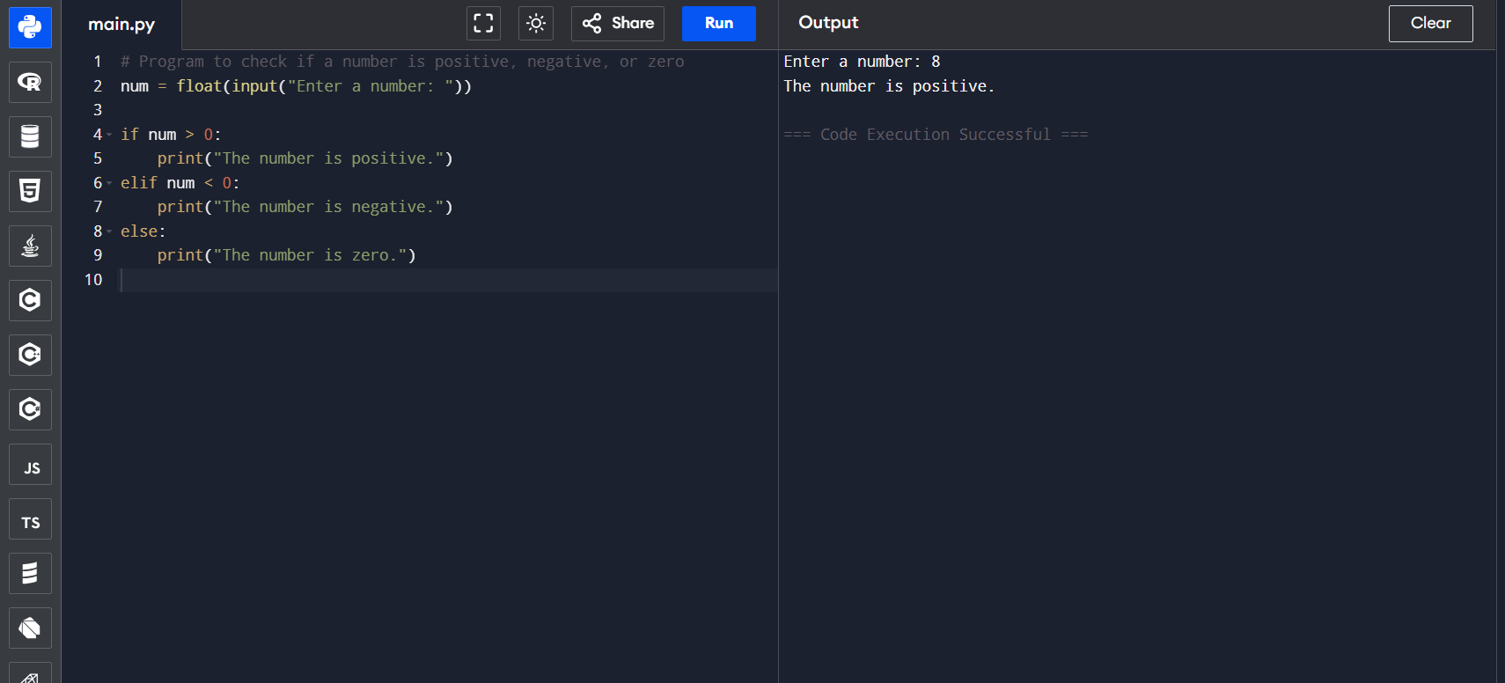 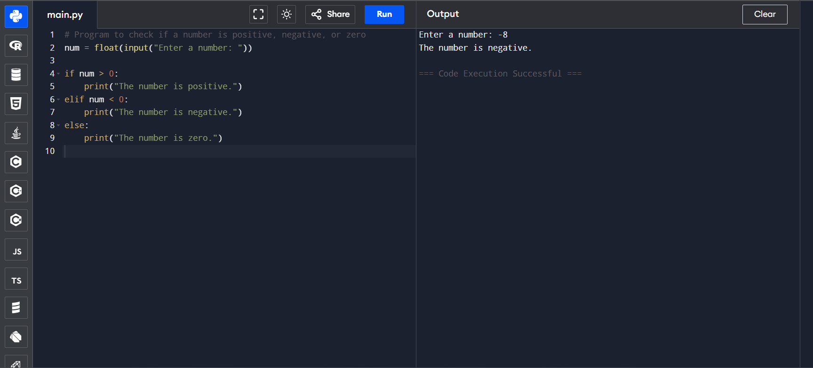

Question : Create a program to determine whether a given year is a leap year.

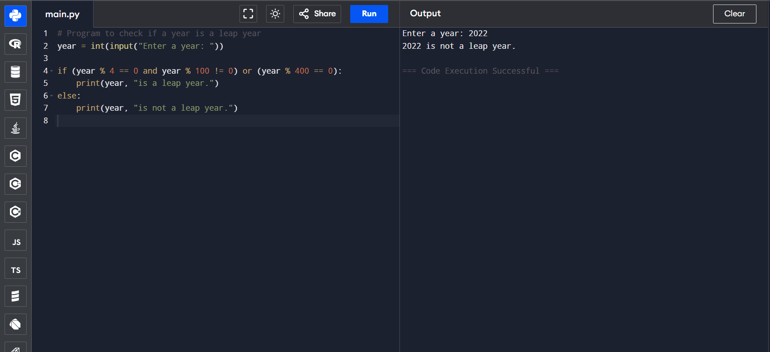

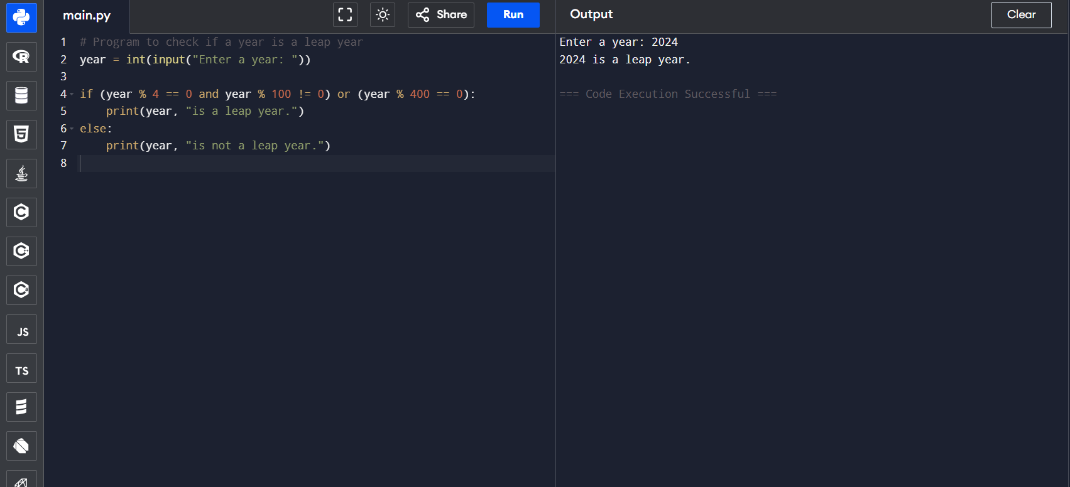

Question: Build a simple calculator that asks for two numbers and an operator (+, -, *, /) and prints the result.

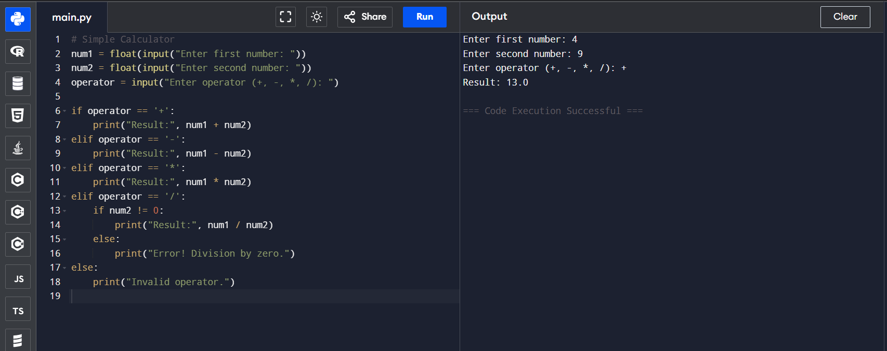

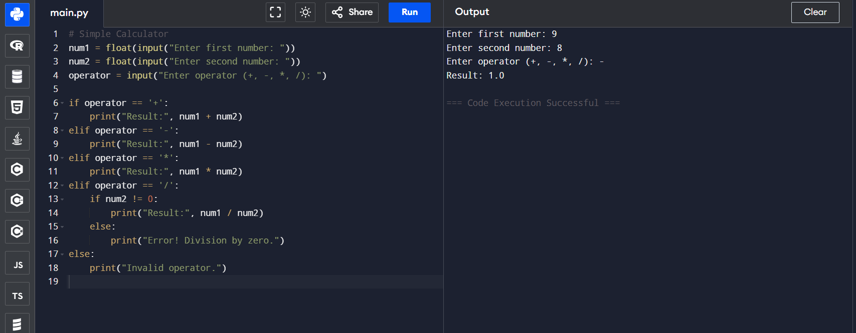

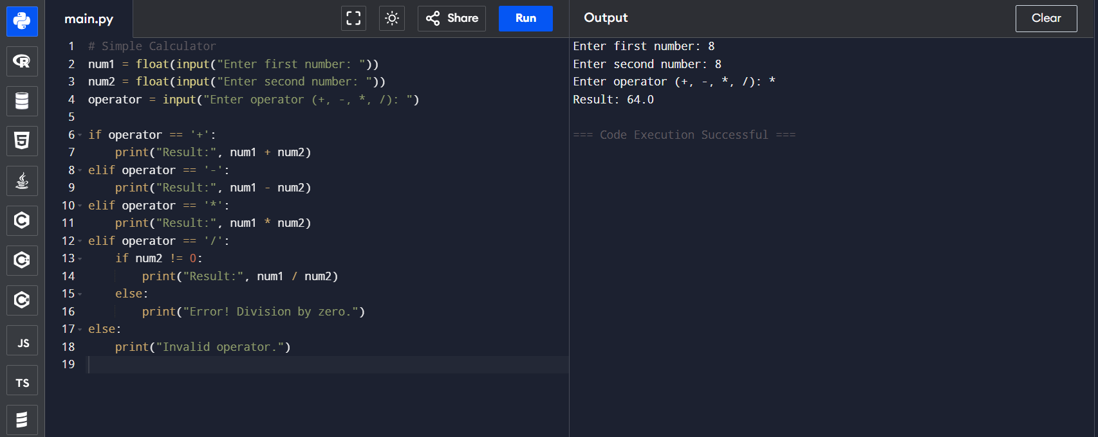

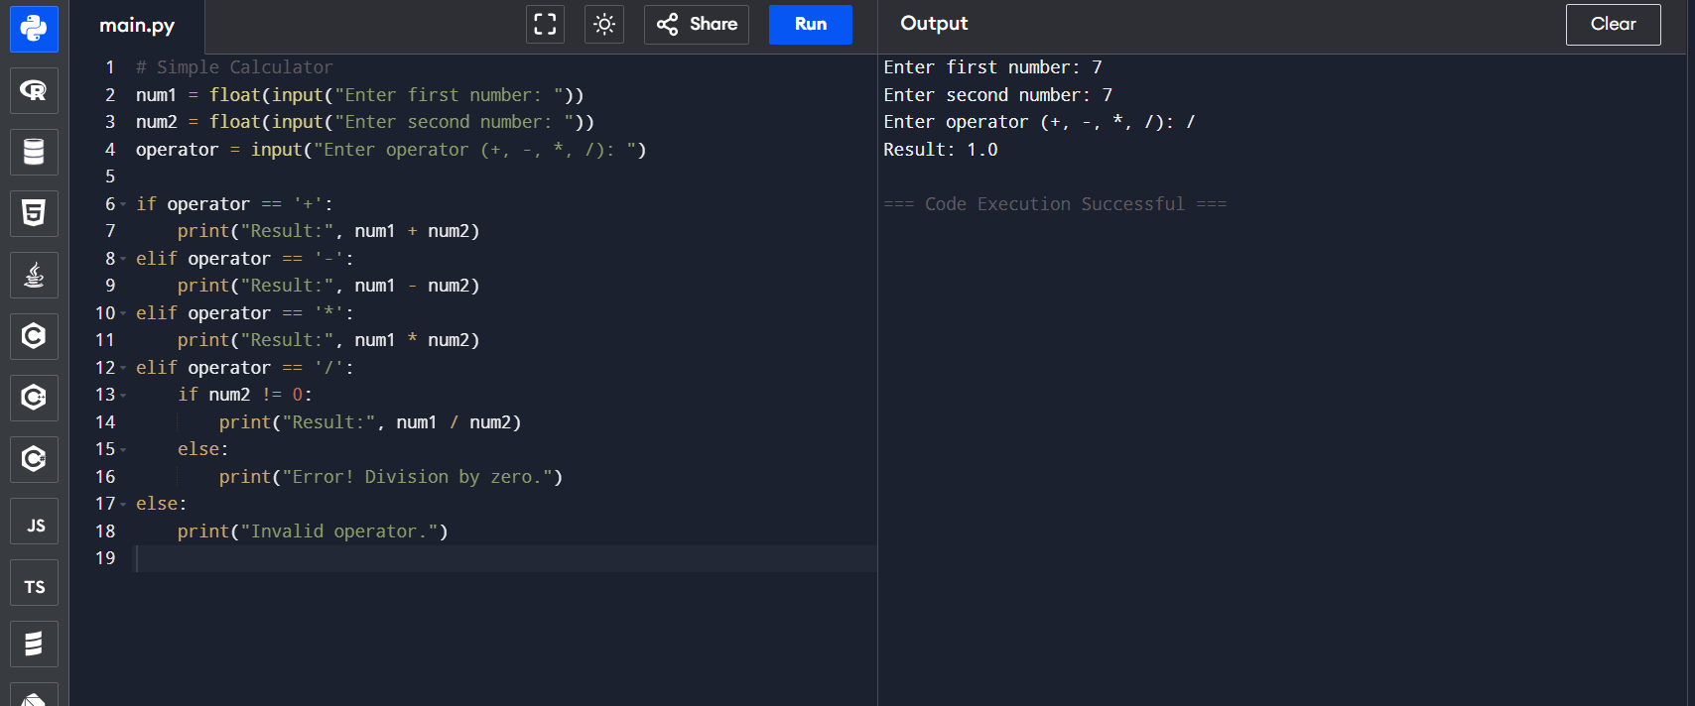

**Question**: Write a Python program that accepts a student's marks and prints the appropriate grade based on the following criteria:

* A: 85 and above
* B: 70 to 84
* C: 50 to 69
* F: Below 50

